**GATE ENTRY - MATERIAL INSPECTION (MANUFACTURING DATE, EXPIRY DATE, RETEST DATE):**

1. Expiry date / Retest date is Mandatory field, but option given for “Not Applicable” for materials not required to display Manufacturing Date, Retest Date, Expiry Date.
2. Manufacturing date is manual entry from Delivery Challan/Material COA/Inv. No.
3. If vendor expiry date mentioned then enter the same in expiry date field; accordingly, system will calculate the remaining days for expiry.
4. If vendor retest date is mentioned in Delivery Challan, enter the same in Retest Date field and system will calculate remaining days to retest accordingly.
5. In case of vendor retest date given – The expiry date field is mapped from Material Master (Mfg Date + Shelf Life of Product = Exp Date). Accordingly, system will calculate remaining days for expiry.

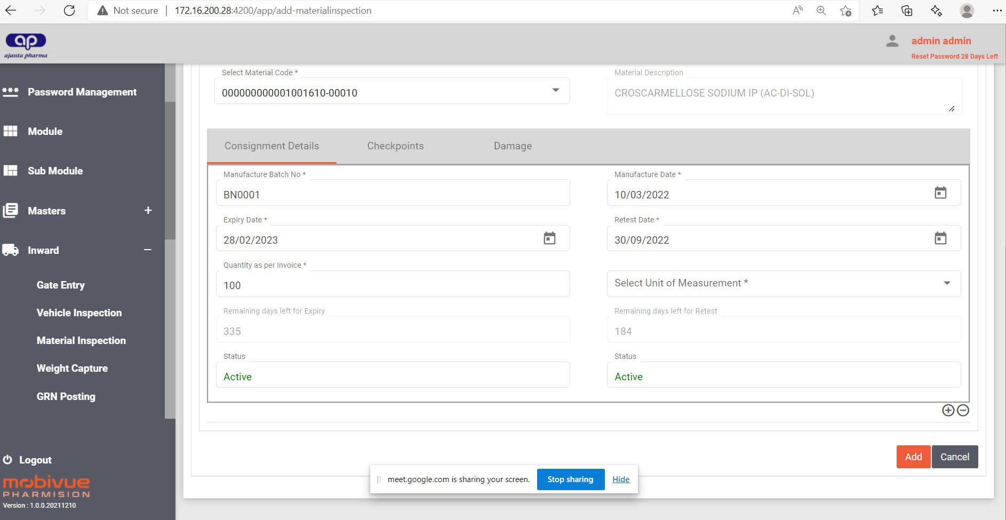

**POPUP MESSAGE FOR MATERIAL (EXPIRY DATE /MANUFACTURER RETEST DATE / IN-HOUSE RETEST DATE)**

1. If the expiry date / Mfgr. Retest Date / In-House Retest date is less than 15 days, the alert message in WMS user UI after each Log In.
2. The user acknowledges the message and proceed for other activities. Each and every time the user Login to WMS UI, the PopUp Message should appear on the screen.
3. The message will PopUp, until the Material Status changed to “Quality Inspection” Generation of “Inspection Lot No”.

**Expiry Date:** Mapped from Material Status Label.

**In-House Retest Date:** Mapped from Material Status Label after QC Release.

**POPUP MESSAGE UI DISPLAY SCREEN:**

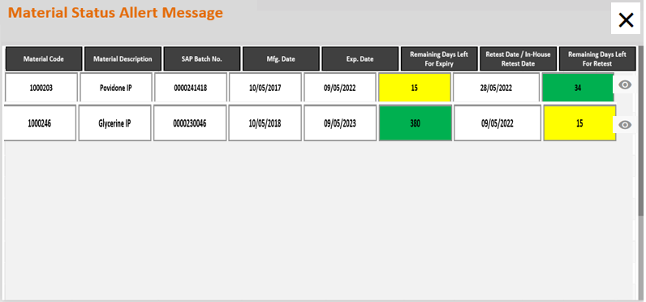

**View Details:**

Click on view to check the material details.

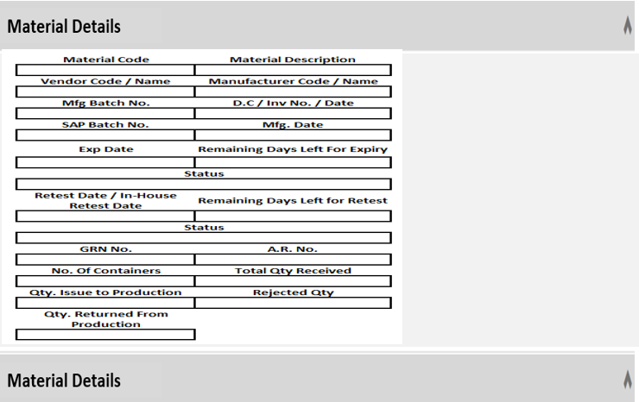

**Balance Qty of Retest Material:**